[[1]](#footnote-1)

Team Description Paper: Team Emerotecos

Felipe Nascimento Martins1, André Seidel Oliveira2, Gabriel Lima Guimarães3, Ivan Seidel Gomes4, Matheus Pimentel Canejo Pinheiro da Cunha5

*Abstract*— This paper presents a description of an omnidirectional robot to be used on the Rescue B competition. The main robot controller was written in Java and runs in an Android-based mobile phone. The phone is connected to an IOIO board that serves as an interface between the main controller and the robot’s motors and sensors. The IOIO board connects to an Arduino board, that is responsible for the distance and temperature sensors readings, and to an MBed board that controls the motor drivers. There are four infra-red distance sensors mounted on a rotary base on the top of the robot. The base angle is constantly changed by a servomotor, which allows a 360º distance measuring. The robot mechanical structure was designed using a 3D modeling software and was built using acrylic. It has four omnidirectional wheels that allow the robot to move in any direction without the need of turning itself. The robot was entirely designed, built and programmed by the team students.

# Introduction

This is to show team Emerotecos’ strategies to solve the challenge proposed to the Rescue B Competition.

To build the robot, we didn’t use any building kit, as we designed the whole robot from sketch, using Dassault Systemes’ Solid Works software [1]. The robot was built basically with 5mm thick acrylic pieces, whose are tough enough for the application.

As the main processor, we use an Android phone, which is programmed using Java. This is a very interesting platform to work with since nowadays Android is the world’s most popular mobile platform [2].

To send the signals from the Android to the motors (that are controlled by an MBED board [3]), we use a board called IOIO, which is responsible for reading all the sensors as well [4].

# Objective

The objective of this project is to build a smart robot that can cross a maze build with wood walls, and identify the electrically heated victims that are placed along the maze’s walls.

# Ambient

The Challenge happens in a modular arena, made with wood, which has 2 floors, and 4 main rooms. The location of the walls are always unknown by the time the robot starts running, so that it runs in a real maze. The only constant information about the arena, is its total size, what makes it easier to the robot to find its way on the place. An illustration of the maze is shown in Figure 1.

Some heated “victims” are randomly positioned on some walls in the arena, and the robot has to identify them to get points.

In some places, there are some “dead ends”, which are a black mat on the ground. The robot can run over these black mats, but it has to leave it on the same side it came from, it can’t cross the black area.

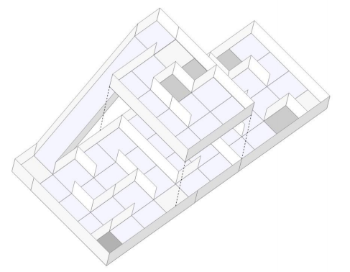

1. Rescue B Arena illustration.

# Strategy

## A. Structure

Our robot is built basically with 2 acrylic layers, and some acrylic beams. We use a Mecanum omnidirectional wheels system, which makes our robot able to drive to every direction. The Mecanum system works as a regular omni system, but it uses 4 tractioned wheels, instead of three, normally used. Figure 2 shows the robot design and Figure 3 shows the actual robot, without the control boards.

We use 4 very strong motors, with encoders, so that we can precisely move our robot everywhere.

To make good measurements with the infrared distance sensors, we’ve put them in a turnable head over the robot, so that we can make meausures to every direction.

To identify the victims, we have 4 thermal infrared sensors startegicaly positioned around the robot, so that we can measure temperatures in every wall.

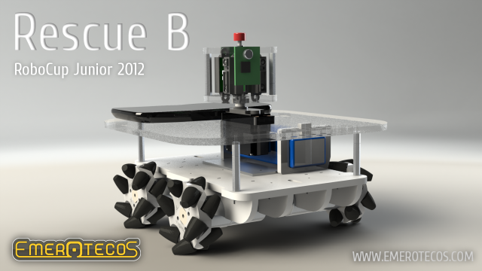

1. Robot design.

#### Info_06

1. Robot picture(without control boards).

#### As you can see in the Figures 2 and 3, the distance sensors are positioned on rotary base on the top of the robot. This base is driven by a servomotor so that the sensors can be aimed to virtually any direction.

Its visible too how are the Mecanum wheels mounted on the robot, similar to a Four by Four car, but with the capacity of moving to any direction without the need to turn.

## B. Programming

The main controller of our robot is an Android cellphone. We choose Android, because it’s a very open platform [2], and it’s possible to connect the cellphone with the sensors easily, using the IOIO board [4].

To move the robot, we use a kind of SLAM (Simultaneous Localization And Mapping) algorithm, so that we can map the arena. While the robot walks around the arena, we can see the map being formed on the cellphone’s screen. Maping is the best way to solve this challenge, because it makes it easy to visit every module of the arena, and consequently, find all victims.

The SLAM was programmed in JAVA, and it runs on the Android. The Android sends and receives data to/from the IOIO, which reads the sensors, and communicates with the MBED board, the one responsible for controlling the motors. Figure 4 shows the control system overview.

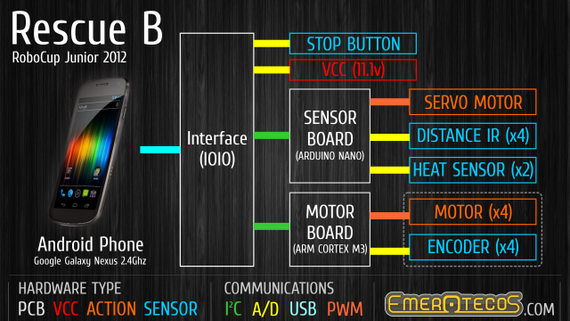

1. Control System overview.

# Acknowledgement

The authors thank the following companies for the financial support that allowed the robot construction and participation at the competition: Proesi Componentes Eletrônicos, Nova Didacta, InTechno Desenvolvimento e Capacitação, Copy Express, Produtiva Hailtools, Use Móveis para Escritórios e Qualidata. They also thank IFES for the support and FAPES (a foundation of the Secretary of Science and Technology of the State of Espirito Santo, Brazil) for the financial support to pay for the air tickets and travel expenses to Fortaleza – LARC 2012 (Project 57768773/2012).

References

1. 3D CAD Design Software SolidWorks. Available at: <http://www.solidworks.com/>. Access: Sep. 5, 2012.
2. Andoid, the world’s most popular mobile platform. Available at: <http://developer.android.com/about/index.html>. Access: Sep. 5, 2012.
3. Mbed - Rapid Prototyping for Microcontrollers. Available at: <http://mbed.org/>. Access: Sep. 5, 2012.
4. IOIO Documentation. Available at: <https://github.com/ytai/ioio/wiki>. Access: Sep 5, 2012.

1. The authors are with the Federal Institute of Education, Science and Technology of Espírito Santo (IFES). Rodovia ES-010, km 6,5 - Manguinhos, Serra, ES.

   felipemartins@ifes.edu.br1, andre\_oliveira@live.com2, gablg@hotmail.com3, ivanseidel@gmail.com4, pimentelcanejo@hotmail.com5. [↑](#footnote-ref-1)